Nakayoshi Gakko
Arts and Crafts Committee

Grade: Zou

Project: Shi-Shi Lion Puppet

Material: Kamaboko Boards, Sandpaper

Qty. Needed: (17) Sets of cut and drilled pieces

Instructions: Cut each kamaboko board into 2 pieces: One 2” x 2” piece, and one 2” x 4” piece. Drill holes through both pieces according to sample. Holes must be large enough for students to thread ribbon through.
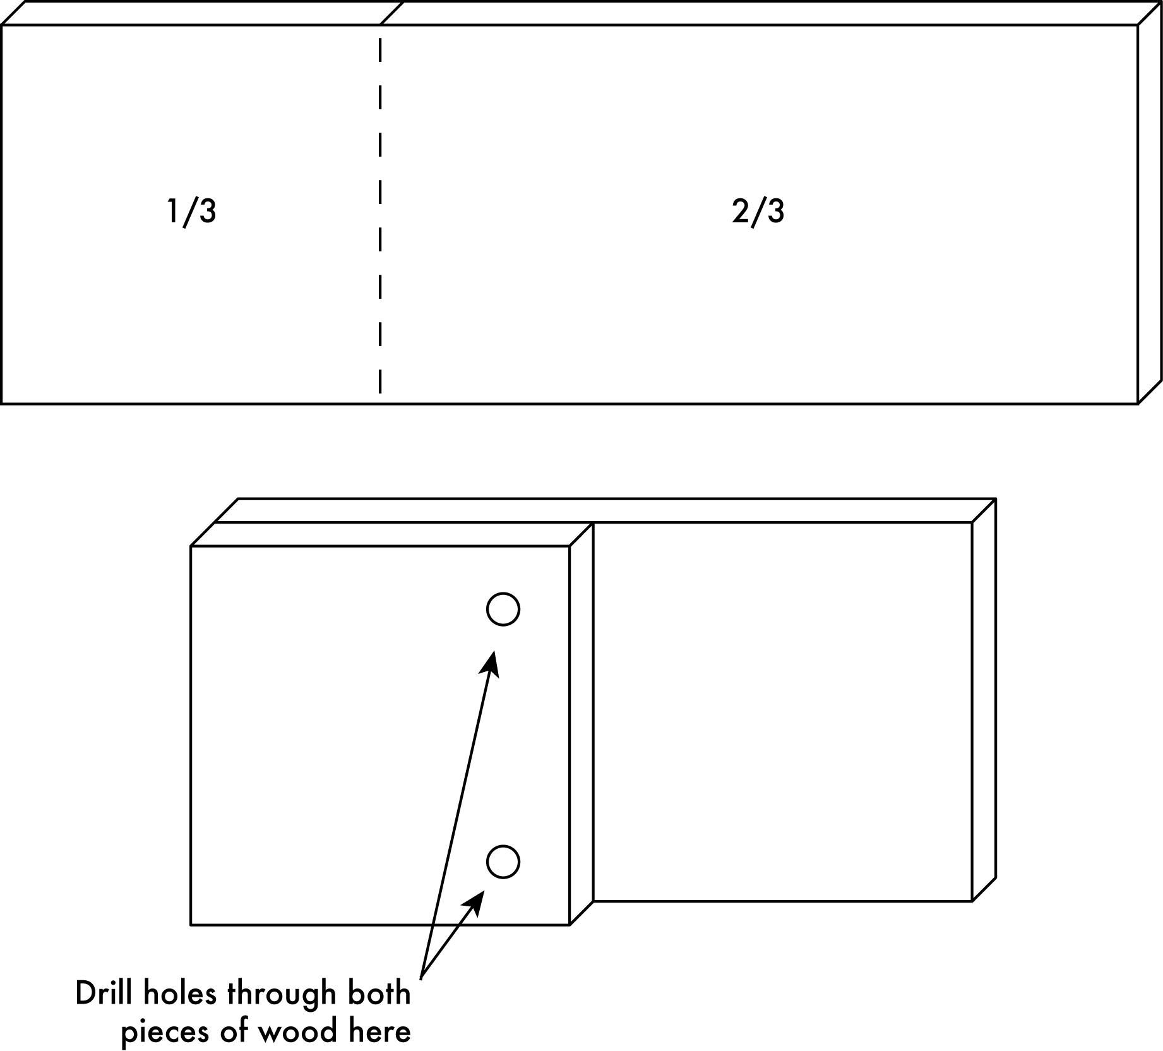

Due Date: Bring completed project with you on Maintenance I day prior to the start of the session. Please return sample and any unused materials.

Thank you in advance for your help. ☺

